Sales Plan Template

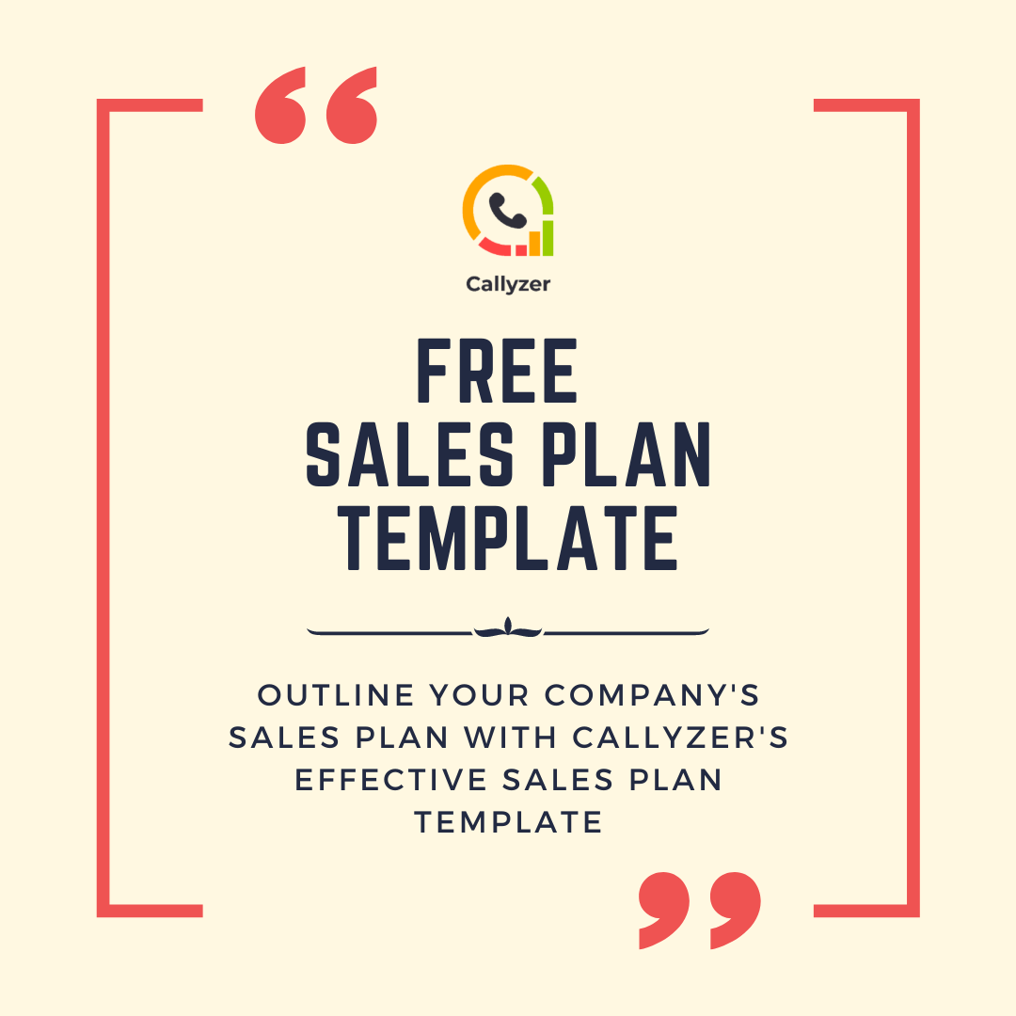

How to use this template?

This template can be used to create a fundamental sales plan for your early-stage, pre-seed, or even established startup.

The template lets you document the answers to some of the most crucial questions you need answers to when it comes to sales processes. In the retrospect, you’ll have an actionable sales plan that works.

Here’s what this sales plan covers:

- Sales goals — what do you want to achieve?
- Tactics — The process, activities, and strategies
- Timelines — The time you’ll need to make things happen
- Sales KPIs — the metrics you’ll track to determine success

To know more on how to use this template, check out our exhaustive guide on building an actionable sales and marketing plan.

What to Include in Your Sales Plan [Checklist]

Sales Plan Checklist

B2B sales is hard and can get confusing. But you can simplify the process of creating a sales plan by answering a few questions related to sales strategy. Here’s a quick checklist to turn the basics of any sales strategy into actionable ideas for a solid sales plan.

Section | Things to Keep in Mind
Goals | What is your SMART GOAL? Is it:  - Specific  - Measurable  - Actionable  - Relevant  - Time-bound  Some examples include:  - Nurture more MQLs into SQLs, and ultimately, customers  - Reduce your churn rates  - Expand your sales team to nurture and convert leads faster  - Increase the customer lifetime value through upsells or cross-sells  - Expand your sales activities into new territories or regions  - Optimize your pricing strategy to improve your conversion rates
Tactics & Strategies | - What do you need to do to achieve your goals?  - How will you do what you need to do?  - How will you attract leads?  - How will you qualify leads?  - How will you nurture leads?  - How will you convert the leads?  - What steps your team will take to turn a sales-qualified lead into a customer?
Timelines | - How much time will you give to measure the success of a tactic?  - What is the intended course of action during this time?  - Who will be responsible to ensure that the timelines are met?
Growth KPIs | - How will you measure success?  - Is your measurement criteria linked to your underlying sales goal?  - Why is this KPI important in your conversion funnel?  - Who is responsible for achieving a KPI?
Alignment | - How will your sales and marketing team coordinate on a daily basis?  - Do you have the tools to ensure streamlined information transfer between sales and marketing teams?  - How will you track collaboration and alignment?
Supplemental Info:
Supplemental Info:

Download a Sales Plan Template

Table of Contents

- Goals …………,…………………………………………………………………………........xx
- Tactics & Strategies ……………………………………………………………………..xx
- Timelines …………………………………………………………………………....…..xx
- Growth KPIs ………………………………………………………………………….....xx
- Alignment ……..……………………………………………………………………...…..xx

Goals

In this section, add:

- What is your one SMART goal from the sales strategy?

- Is this goal Specific? If yes, write down how specifically will it lead to more sales for your company?

- How will you measure the success of your team, tactics, and strategies to achieve this goal?

- What are the proposed tactics and strategies you’d take to achieve this goal?

- Is someone else in your industry chasing the same goal? If yes, add examples from your competitor analysis?

- How soon do you want to achieve this goal?

Tactics & Strategies

In this section, add:

- What is the best way or strategy to achieve the goal? (Inbound/Outbound/Other)

- How will you embed your sales tactics in the buyer’s journey?

- What are the channels you’ll adopt to amplify the sales?

- Break down your goal into daily activities that your team will undertake daily

- How will these day-to-day activities aggregate into a long-term movement on the sales charts?

- Who will be responsible for performing the daily activities? (Break down based on each of the channels/tactics)

- Do you need any tool or solution to do the daily sales activities?

- How will you embed your sales tactics in the buyer’s journey?

Resources
- Sales and Marketing Strategy
- What is revenue generation?

Timelines

In this section, add:

- How much time will you give to each sales tactic you will adopt? (add separate timelines for each sales tactic/channel)

- What will you do in case of delays/hold-ups?

- How will your team understand the relationship between their daily activities and long term goals?

Growth KPIs

In this section, add:

- What KPIs are really crucial for the success of these sales strategy?

- How will you record progress on these KPIs?

- Do you need any tools or analytics reports to track success? If yes, how do you plan to integrate in your process?

Alignment

In this section, add:

- Is your current sales and marketing teams aligned? If yes, document specific instances of workflow between sales & marketing to fuel each sales tactic you’ll adopt.

- Is your marketing and sales goal aligned at all levels within your team?

- Do your sales and marketing team members agree on lead and conversion terminologies?

- How often do your marketing and sales team meet to align their day-to-day deets?

- What is your sales enablement plan? How will you align market needs with your sales strategy?

- What are the challenges to sales-marketing alignment to achieve your goals?

- How do you propose to tackle these challenges in the short and long run?

- Is your team tech-enabled to align the sales and marketing processes?

Annexure

Target Audience Personas

Competitor Research

Job Roles & Responsibilities

Key Performance Indicators

Marketing Budget & Forecasts

Notes & References

